Power BI Project Report
Farah Jarrar
Supermarket Sales Performance Report
1. Key Performance Indicators (KPIs)
- This section displays five core summary cards including Total Sales ($8.69K), Total Transactions (25), Total Gross Income ($413.73), Total Quantity (146), and Average Customer Rating (7.47).
These metrics provide management with an instant, high-level overview of the supermarket's financial and operational health.
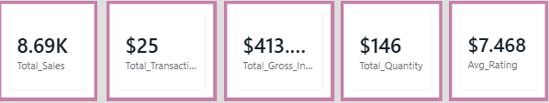

2. Total Sales by Product Line & Customer Type
- This stacked column chart compares total sales across six product lines, segmented by customer membership type (Member vs. Normal).
- It highlights that "Sports and travel" is the top-performing category, while showcasing buying behaviors within each product line.

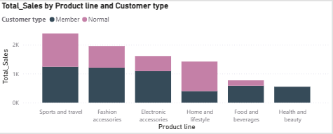

3. Total Sales by Branch (Pie Chart)
- This pie chart illustrates the percentage and relative share of total sales contributed by each supermarket branch (A, B, and C).
- It shows that Branch A leads with 40.45% of total sales, followed closely by Branch C (31.09%) and Branch B (28.46%).

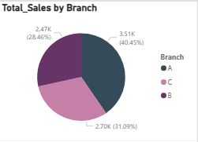

4. Product Performance Summary Table
- This customized data table provides precise numbers for product lines, tracking their total quantities, sales, gross income, and average ratings.
- It serves as a detailed reference for management to audit exact numbers and evaluate product profitability directly.
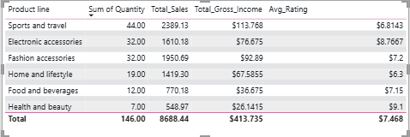

5. Gender Slicer
- This interactive slicer allows users to filter the entire dashboard by customer gender (Female or Male) with a single click.
- It enables seamless, dynamic analysis of purchasing trends and behavioral differences between male and female shoppers.

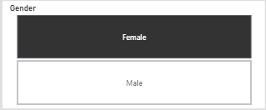

6. Average Rating Gauge Chart
- This speedometer-style gauge measures the overall customer satisfaction score on a strict scale from 0 to 10.
- It visually communicates that the supermarket is performing well with an encouraging average rating of 7.468.
